Quite a lot happened Saturday, August 2019, in the Boston Common.
By about quarter to 1 PM it was clear that almost everybody agreed that “We Won”, as I heard a woman say to relief and applause! She was, it seems, speaking to and for people of one or more of the following active political inclinations:
- anti the permitted rally with this agenda
- against – Fascism / Nazism
- for Black Lives Matter
- a neverTrump person
- for inclusiveness in most or all forms
Here is the roughest sort of guess as to the % of people most intensely focused on each concern:
- anti the permitted rally with this agenda (regardless of the agenda) 20%
- against – Fascism / Nazism 30%
- for Black Lives Matter 20%
- a neverTrump person 20%
- for inclusiveness in most or all its various forms 10%
The main way one could readily tell how many of each persuasion were present was by the Mini-tweet signs that maybe 3 or 4% of people were carrying.

But the main thing I can offer is something you is a few words on a thing I encountered by chance. As I was waiting for the promised loudspeaker statements, debates, appeals, assertions, whatever, I heard behind me a Huh, huh, huh,…Huh, huh, huh chanting in unison. And I began to realize that the sound was – moving!
When I turned around to look, I saw two side-by-side conga lines of people, perhaps 12 or 15 people long (a quarter-hundred or more people) trotting along, side by side, chanting. They were all dressed identically in somewhat loose-fitting black, with a thin black bandanna over their lower faces. They rather quickly headed onto the path I was on and on it up toward the Soldiers and Sailor’s Monument. I asked a lady nearby what that was and she said ANTIFA. When I asked “what’s ANTIFA?” she said something about actively supporting the rally protestors.
That would have been it except for Manny from Brockton, a person I become acquainted with a bit later. As I discussed the ANTIFA thing with him, he expressed surprise that these ANTIFA marchers were thought to be friendly to the protestors. He had “learned” that this group of chanters were in support of the Free Speech Rally people-with-the-permit. He also said that there were two versions of the Huh, huh, huh chant. One of the two has an extra word at the end which inverts the “fact” being chanted. Into its inverse!! As we jointly developed this understanding Manny went over to yet others who were in the path of the chanters. He came back and told me that this additional source of understanding was the same as mine. He’d also been told that they wore masks for protection. Not from being arrested or prosecuted, but because the Fascist Nazi thugs they might fight against were going to take pictures of them, find out who they were, and harass them! As we parted, Manny said that he was glad that he’d not gone off with an understanding that could be false.
I have to say that it’s hard for me to see these individuals as having come to Boston Common as individuals, because of their personal belief and at their own expense and easier for me to see them as a group performing a scripted activity and paid for their performance. Their behavior was downright weird!! I saw nothing even faintly similar the entire rest of the day.

Whatever the truth is for Boston, it seems that it’s quite possible that now people and the press must always expect fake groups taking actions at rallies which distorts or reshapes the apparent outcome. Because somebody paid them well to do it.

Postscript:
Here is the Crowds on Demand information that arose in the Charlottesville context.
Craigslist ad:

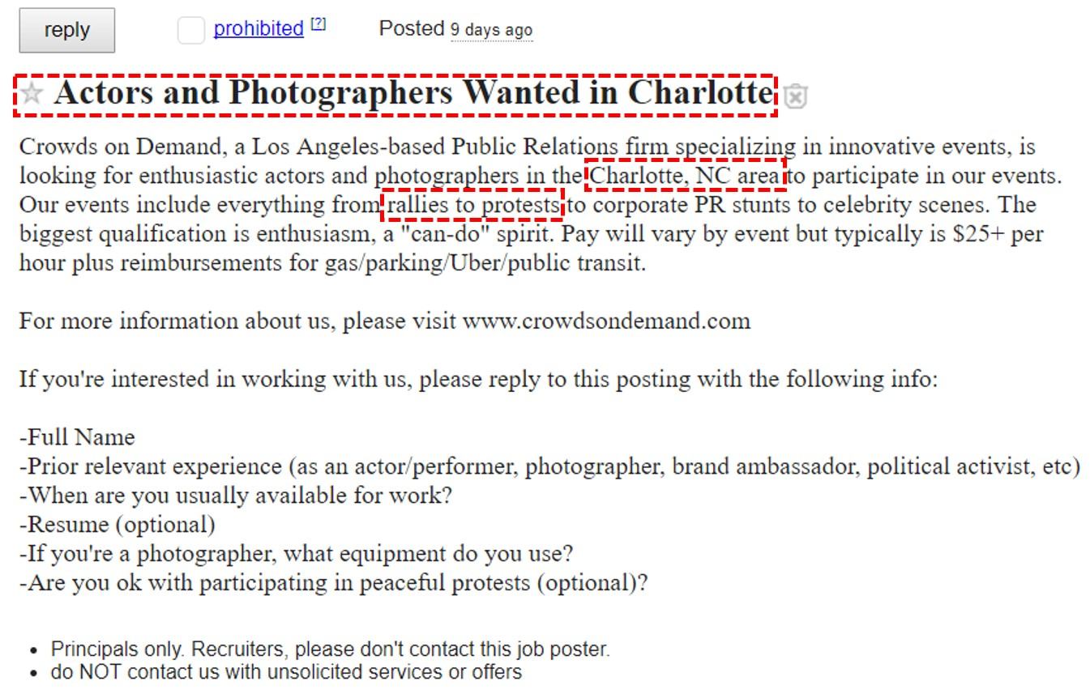

According to their own website, they're in the business of sourcing large crowds of people to "provide clients with protests, rallies, [and] flash-mobs" all over the country.
They have an entire page on their website dedicated to "Protests and Rallies."

"The CEO of Crowds on Demand denied to Snopes that his firm was involved in the Charlottesville protests but refused to provide details on the specific purpose of the craigslist ad and/or why it was temporarily removed yesterday before being restored."

Antifa

Here's one attempt to define it: http://www.urbandictionary. com/define.php?term=antifa
Here is a Wikipedia article on it: https://en.wikipedia.org/wiki/Antifa_(United_States)
Here is how it's trending. (From Google Trends, which is accessible via homeplace.)

